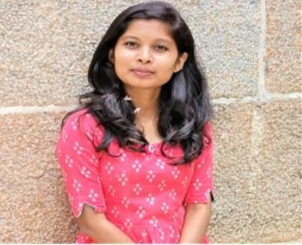CT ROJA

Contact :(+91)7625090147

E-mail: [rosathiru028@gmail.com](mailto:rosathiru028@gmail.com)



# CAREER OBJECTIVE:

To give my best to the organization through my knowledge and my capabilities, in turn ensuring personal growth within the organization. I assure that my technical and communication skills will help me face the challenging tasks and pursue energizing career.

# PERSONAL INFO:

**Nationality:** Indian

**DOB:** 28th April, 2001

**Father:** Thirumalaiah C T, Farmer

**Mother:** Lakshmi M B, Home maker

**Languages known:** English, Kannada, Telugu

# EDUCATIONAL QUALIFICATION:

|  |  |  |  |  |
| --- | --- | --- | --- | --- |
| **COURSE** | **BOARD/ UNIVERSITY** | **INSTITUTION** | **YEAR OF PASSING** | **RESULT** |
| B E/B Tech | Visvesvaraya Technological University | Channabasaveshwara Institute Of Technology | 2022 | 7  (CGPA) |
| Class 12th | Karnataka state board | Narayana PU college | 2018 | 71.2**%** |
| Class 10th | ICSE | Varin International Residential School | 2016 | 76.6% |

## SKILLS:

**Soft Skills:**

* Team Player
* Better as communicator
* Good Adaptability

## Technical Skills:

* Core Java
* JDBC
* SQL

# TECHNICAL PROJECTS:

* Automated path following bot with automated sanitizer sprayer.

# PARTICIPATION & CERTIFICATION:

* Workshop on Data Science at BITS PILANI – Hyderabad.

# DECLARATION:

- I hereby inform that the above mentioned details are true and correct as per best of my knowledge.

**(CT ROJA)**